CREATION OF AUTHOR COMPONENT USING AEM

1.NAVIGATION PAGE OF AEM

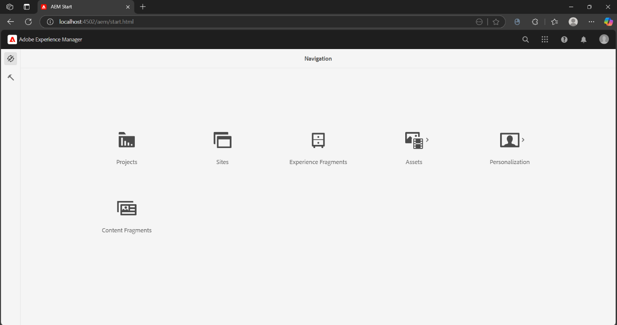

2.TOOLS PAGE IN AEM

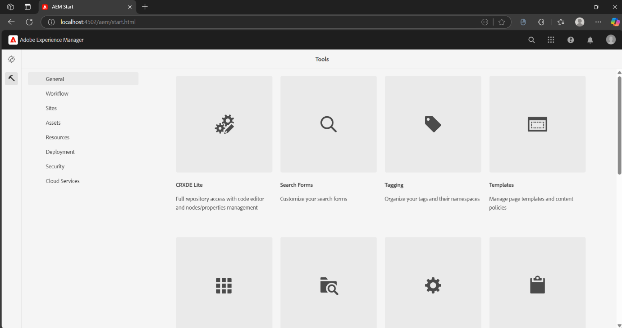

3.HOME PAGE OF CRXDE LITE

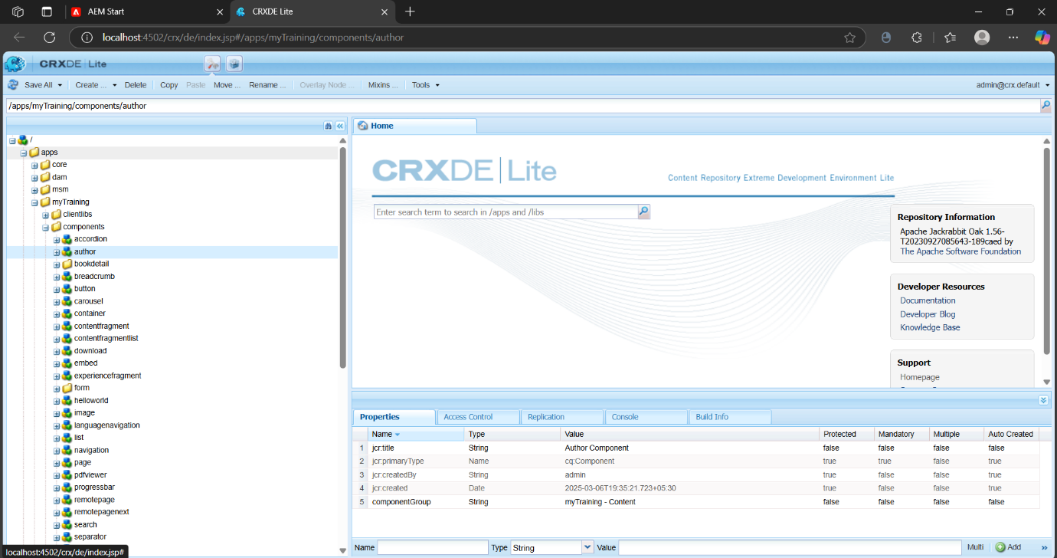

4.CREATION OF author COMPONENT

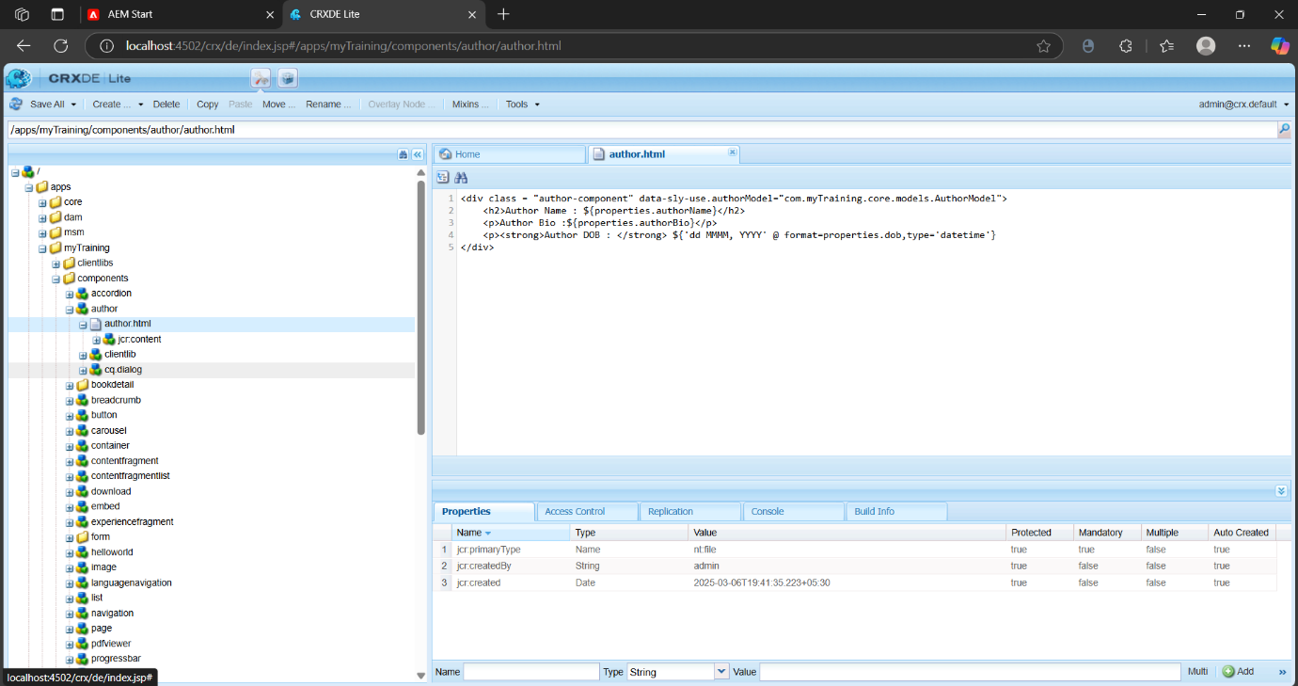

5.ADDING .html AND .css FILES TO THE COMPONENT

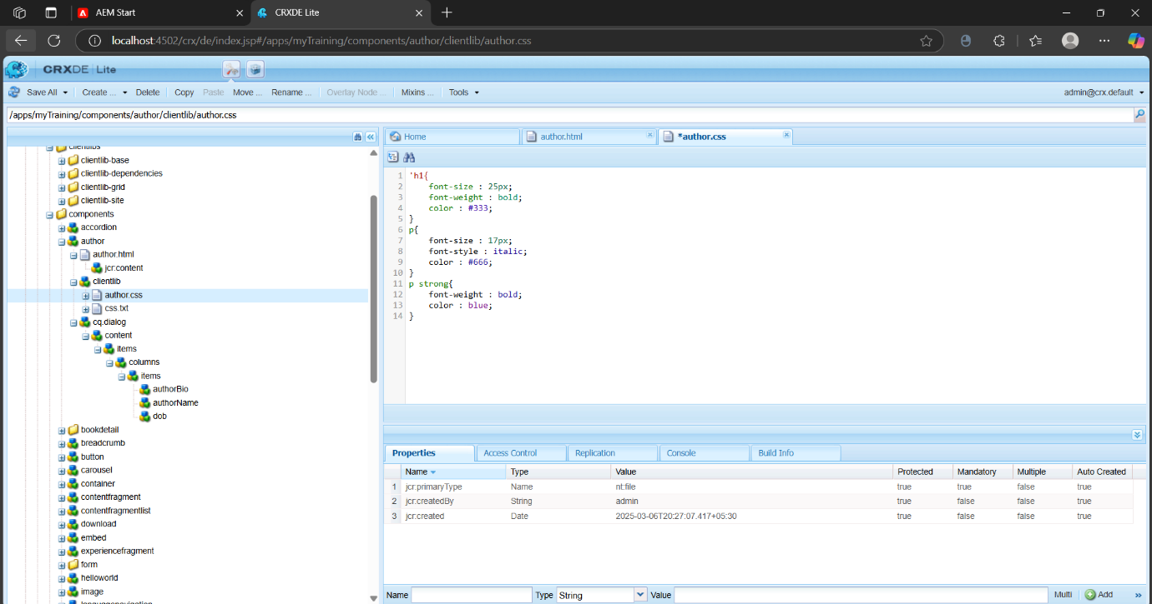

6.ADDING authorName , authorBio, dob NODES

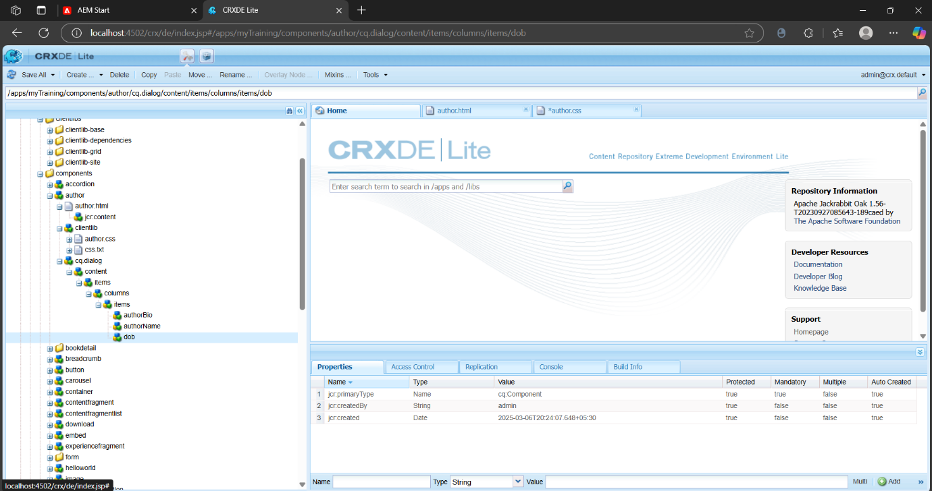

7.OUTPUT PAGES

